【Thriller】 顫慄
Michael Jackson麥可傑克森
'Cause this is thriller, thriller night
因為這是顫慄之夜
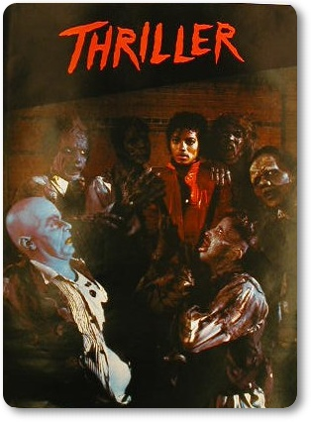
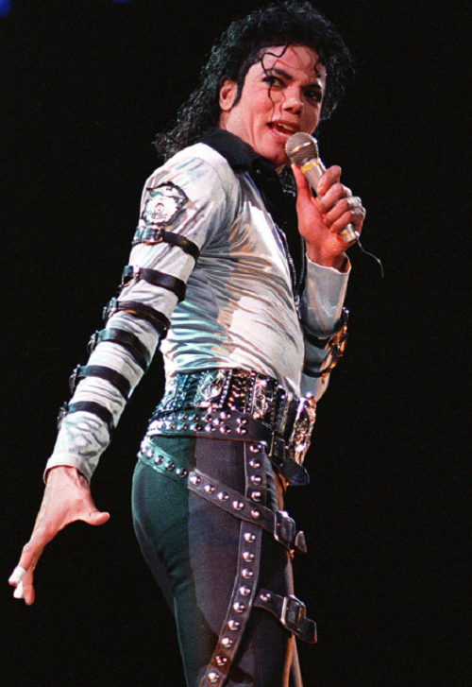
And no one's gonna save you
沒人能救你於
From the beast about strike
猛獸之口
You know it's thriller, thriller night
你看，這就是顫慄之夜
You're fighting for your life
要活命，就要拼搏
Inside a killer, thriller tonight
在這個陰森的顫慄之夜

